**Usability Testing**

1. **Implement Mockup**

**High Fidelity – Will develop prototype having all functionalities**

1. **Create Usability Test plan**

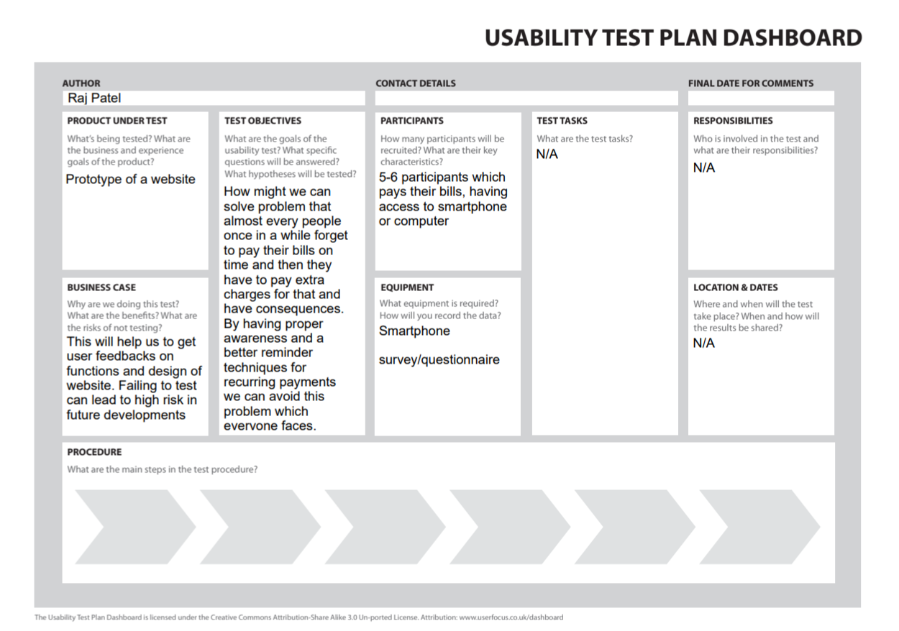

1. **Run tests with 5-6 potential users**
2. **Analyze results, fix design issues**

**Based on user feedback we will improve design feature and functionalities in the application/website.**